SHRISTI 25CSU287
Prompt for roast generator

Write a beginner-friendly C++ console program that generates funny roast messages.
The program should ask the user for their name.
Store at least 10 roast templates in a vector of strings.
Each roast should contain a placeholder {name}.
Randomly select one roast template each time the program runs.
Replace the {name} placeholder with the user's input name.
Display the final roast message.
Use srand() and time(0) to make sure the roast changes each run.
Add comments so beginners can understand the code.

Bug : the code was not running more than one time and the roast was not relate dto coding
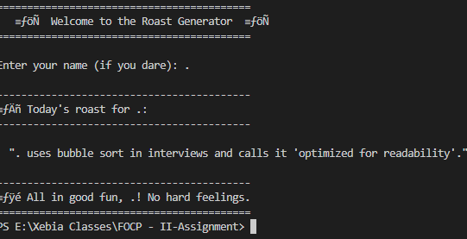

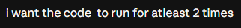
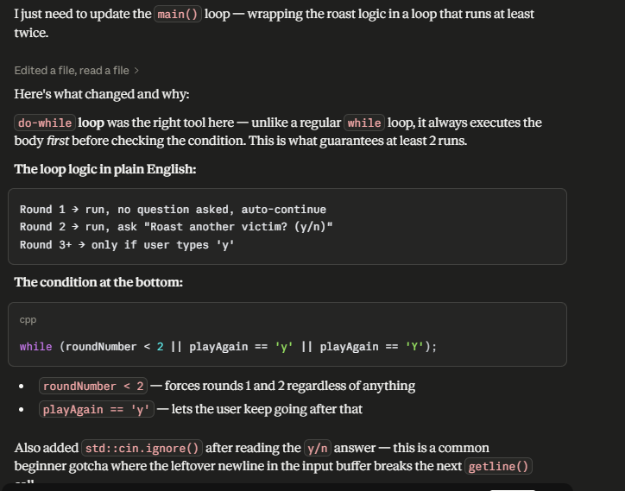
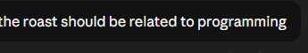
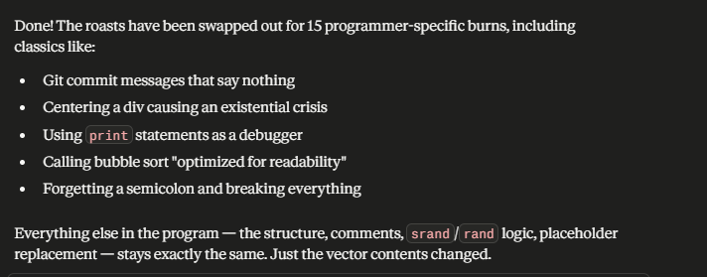

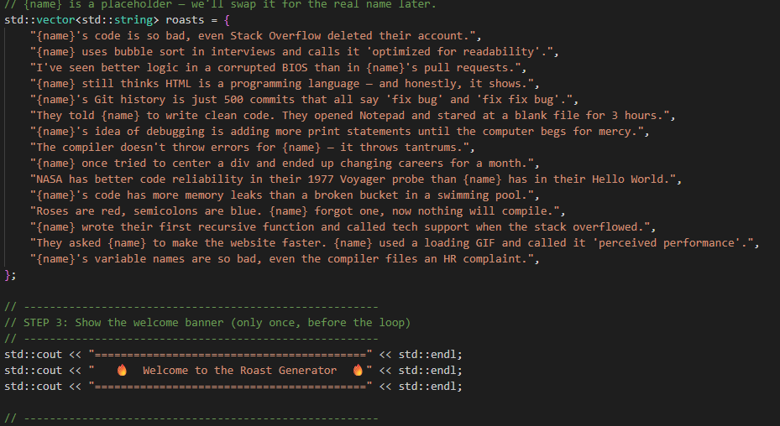

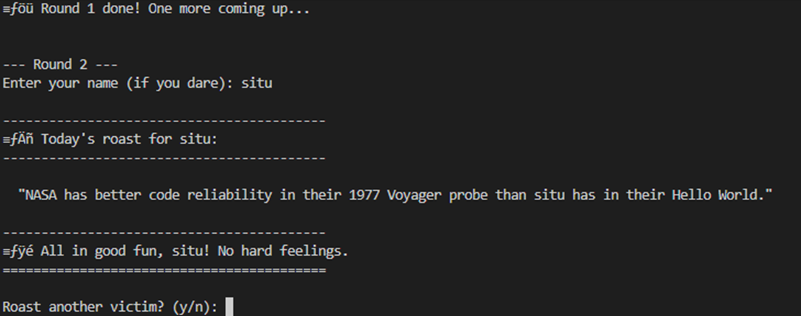
Student execuse generator

Prompt
Write a beginner-friendly C++ console program that generates creative excuses for missing homework.
The program should ask the user to enter the student's name.
Store at least 10 excuse templates in a vector of strings.
Each template should contain the placeholder {name}.
Randomly select one excuse and print it.
Replace {name} with the student's name before printing.
Add comments so beginners can understand the code.

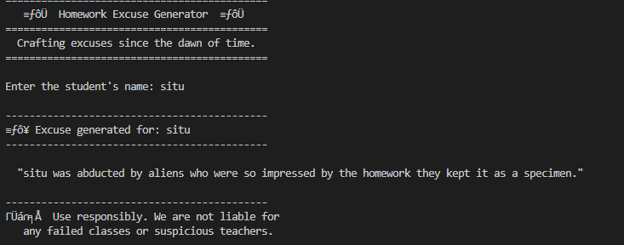

After running again 

